7th Grade Math
Review Packet
April 28th- May 4th

Hey guys! I hope everyone is doing well! I miss you all so much! This is a review test that we would have done to review for our state test, so these are skills that you will need for 8th grade! There is an answer key on the last page, so you will be able to check your work. If you have any questions, please email me at stevensk@stippah.k12.ms.us. Thinking of you all! Stay safe!

Love,
Ms. Stevens

Name: _________________________
Review Test #2

Proportions & Similar Figures
1. $\frac{5}{6} = \frac{x}{12}$ x = _______

2. $\frac{x}{9} = \frac{2}{18}$ x = _______
Set up a proportion to solve for x for each of the following sets of similar figures.

3.
3
9
x
18

x = _______

8
8
4.
4
x = _______
x

Percents, Decimals, & Fractions

Write each fraction as a percent.

5. $\frac{7}{25}$ ____________ 6. $\frac{1}{5}$ ____________

Write each decimal as a percent.

7. 0.64 = __________ 8. 0.32 = ____________

9. 0.10 = __________ 10. 0.08 = ____________

Write each percent as a fraction in simplest form.

11. 15% = $\frac{ }{100}$ = 12. 5% = $\frac{ }{100}$ =

Finding a Percent of a Number
Find the percent of each number listed.

13. 45% of 32 = _________ 14. 7% of 350 = __________

15. 41% of 100 = _________ 16. 2% of 3,500 = __________

Identifying & Classifying Angles
Write if the angle is acute, obtuse, right, or straight.

< A = 104°

17. _____________________ 18. ________________________

< C = 90°

19. _____________________ 20. ________________________

Write if the angles are vertical or adjacent.

2
1
21. < 1 and < 3 _________________
3
4

22. < 1 and < 4 _________________
23. < 2 and < 3 _________________

Triangles
Classify each triangle as equilateral, isosceles, or scalene.
Classify each triangle as acute, obtuse, or right. Then, find x.

20°
24. E/I/S: __________________
14°
x°

25. A/O/R: _________________

26. x = ______________
Polygons
Name each of the following polygons according to their number of sides.

27. 3 sides: ________________ 28. 7 sides: _________________

29. 5 sides: ________________ 30. 9 sides: _________________

Congruent Figures
Determine the correct congruence statements for each pair of shapes.
B
G
F
A
C
H
I
J
D
E

31. $\overline{AB}≅$ _________ 32. $<H ≅ __________$

33. $\overline{CD}≅$ _________ 34. $<J ≅ __________$

Area & Circumference of a Circle
Find the circumference of each circle. Include units! C= πd (3.14 times the diameter)
Find the area of each circle. Include units! C= πr² (3.14 times the radius times the radius again) **radius is half of the diameter**
36.
35.
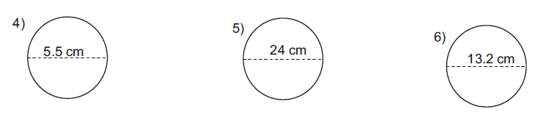
37.
C = ________________ C = _______________ C = _______________

A = ________________ A = _______________ A = _______________
Key:
- 12
- 1
- 6
- 4
- 28%
- 20%
- 64%
- 32%
- 10%
- 8%
- 15/100 = 3/20
- 5/100 = 1/20
- 14.4
- 24.5
- 41
- 70
- Acute
- Obtuse
- Right
- Straight
- Vertical
- Adjacent
- Adjacent
- Scalene
- Obtuse
- 146
- Triangle
- Heptagon
- Pentagon
- Nonagon
- FG
- C
- HI
- E
- C= 17.27 cm, A= 23.75 cm²
- C= 75.36 cm, A= 452.16 cm²
- C= 41.448 cm, A= 136.78 cm²

